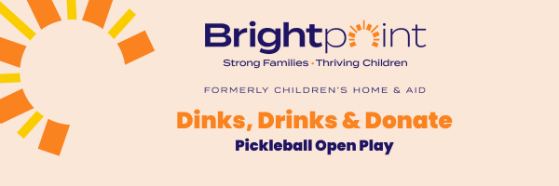

Event Information
Join us for a fun night of Pickleball Open Play
Friday, July 21, 2023
Evergreen Racquet Club
3203 E. Washington St., Bloomington
Sign up now as registration is limited to the first 100 players!
$50 per person
Includes t-shirt - sandwich - adult beverage

Dinks, Drinks, and Donate supports Brightpoint’s (formerly Children’s Home & Aid) mission to help move children and families from surviving to thriving.
For questions contact
Laura Cordero
Senior Development Specialist
lcordero@brightpoint.org
Sponsorship Opportunities
Platinum Sponsor ($1,000)
- Company logo displayed on event signage (logo must be received asap)
- Opportunity to set up display at the event and/or provide a banner for display
- Social media recognition
- Plus, all Gold Benefits

Gold Sponsor ($750)
- Company logo displayed on event signage (logo must be received asap)
- Opportunity to provide brochures or business cards
- Social media recognition
- Plus, all Silver Benefits

Silver Sponsor ($500)
- Company name displayed on event signage
- Verbal recognition at event
- Social media recognition

Bronze Sponsor ($250)
- Company name displayed on event signage
- Verbal recognition at event
- Social media recognition

Thank you for your interest in sponsoring 2023.
Select your level below:

Platinum Sponsorship $1,000 | Gold Sponsorship $750
Silver Sponsorship $500 | Bronze Sponsorship $250

CONTACT INFORMATION:

Return this form to:

Brightpoint
c/o Laura Cordero
403 S. State St.
Bloomington, IL 61701

Via Email:
lcordero@brightpoint.org

Please provide high-resolution company logo for print material by

Children’s Home & Aid
E.I.N. #36-2167743
Contact Name: __________________________________________________

Company: _________________________________________________

Address: __________________________________________________

City: ____________________________ State: _________ Zip Code: _____________

Phone: ______________________ Email: ___________________________________

How would you/your company like to be listed in our printed materials?

__________________________________________________
PAYMENT OPTIONS:

o Enclosed is a check made payable to Brightpoint.

o Please charge my credit card:

Card Number: ____________________________________

Expiration date: _______________________ Sec. Code: _________________

o Please invoice me.

